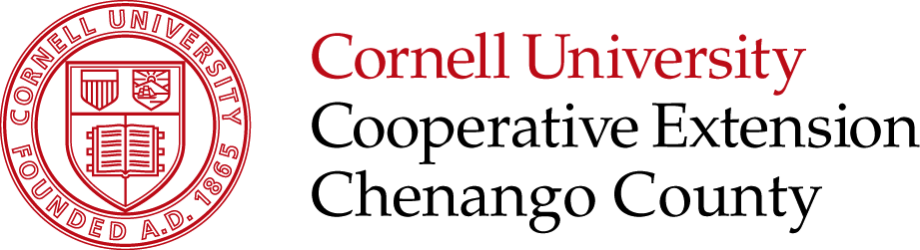

2026 4-H Campership Nomination Form

Return by March 31th, 2026 to: Chenango County 4-H Leaders Association
c/o Chenango County 4-H
99 N. Broad St.
Norwich, NY 13815
Email: 4-hLeaders@protonmail.com

Child’s Name: _________________________________________________________________________ Male / Female

Address: _________________________________________________________________________________________

County of Residence: __________________________________ Number of Years in 4-H ___________________

4-H Club Name: ___________________________________________________________________________________

Child’s Grade Fall 2025: ______ Child’s DOB: ____________ Has the child received a Campership previously? Yes / No

Parent/Guardian’s Name: ____________________________________________________________________________

Parent/Guardian’s Name: ____________________________________________________________________________

Parent/ Guardian’s Primary Phone: __________________________ Secondary Phone: __________________________

Parent/Guardian’s Email: ____________________________________________________________________________

Which camp is the camper seeking to use this Campership at? ______________________________________________

Will the camper be attending a specific camp event? _______________________________________________________

Nomination submitted by: _________________________________________ Relation to child:_____________________

Address: _________________________________________________________________________________________

Email: ______________________________________________ Phone number: ________________________________

The following letters are required for scholarship consideration:
- A letter of recommendation from the camper’s 4-H leader or parents.
- A letter of intent from the camper explaining why they would like to go to camp.

Please return completed form and letter of nomination by March 31, 2026 to the Chenango County 4-H office. Nominations will be considered and recipients notified of their award by April 30, 2026.

Helping You Put Knowledge to Work

Cornell Cooperative Extension provides equal program and employment opportunities. NYS College of Agriculture and Life Sciences, NYS College of Human Ecology, and NYS College of Veterinary Medicine at Cornell University, Cooperative Extension associations, county governing bodies, and U.S. Department of Agriculture, cooperating.

