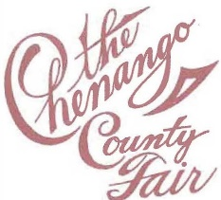
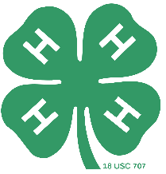

Shirley Proskine 4-H Youth Dairy Award

The Shirley Proskine 4-H Dairy Award is given to encourage youth to begin and continue their involvement in the dairy industry. Each year the award recognizes dairy youth who have shown leadership, dedication, and commitment to the 4-H dairy program.

“When Alynn and Shirley first moved to the farm on Chenango Lake Road in 1955 they opened their home to 4-H club meetings. While having 5 children all involved in various 4-H areas, dairy has remained the primary project area for 4 generations of the Proskine family. Even though Shirley was not seen in the show ring, she always had a seat at ringside watching her children, grandchildren, great-grandchildren, and other 4-H’rs show their animals and demonstrate the things they had learned. She knew the hard work and dedication that was needed to participate in these events and gave her support in any way she could. Often you would hear her exclaim “good job” or see her give a big hug. Her family could also always count on her to have a tasty meal prepared each night of the fair and donuts available on the days they participated in the shows. With this award, the Proskine family hopes to encourage a new 4-H’r to continue spreading the values and qualities that 4-H has to offer. 4-H can take you places! Let this be the help you need to plant the seed and watch it grow!!!”

Selection criteria:
- Three youth involved with the Chenango County 4-H dairy project
- The intent is to encourage youth to begin and continue their participation in the dairy industry
- The award to go to youth demonstrating independence and personal initiative.
- Three cash awards: $100.00, $50.00, $35.00 annually
- To be selected by a 4-H educator or Mr. Proskine following the dairy showmanship class at the Chenango County Fair
- Award to be presented during the awards program at the Chenango County Fair
- Once a youth receives the $100.00 award they are not eligible for any further Shirley Proskine 4-H Dairy Awards

